**GROWTHPAL ASSIGNMENT**

**About the code**

Three files

1)sql-consists of database creation and procedure creation

2)conn.py-deals with the connection code that helps us connect to sql

3)main.py-The file that will be executed and will deal with user input and output.

Output incase of any collision with other meetings

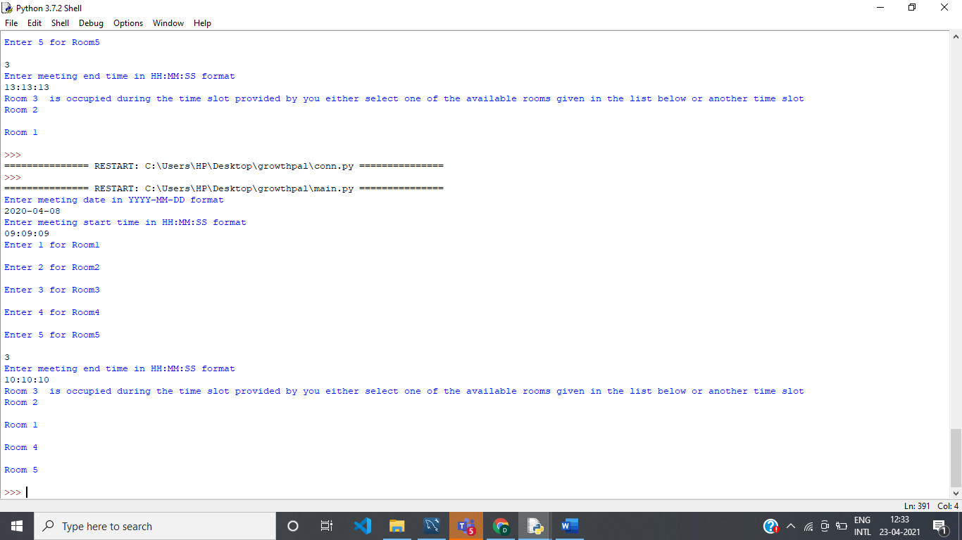

Output incase of no collision with other meetings.

